Project Increment-1

Smart Learn

**Motivation**

The majority of graduate and undergraduate course work suggests books or slides to learn and understand the topics in the curriculum. If the plain textual content is not comprehensive, most of the students either try to byheart or not appreciate the topic they are learning. Short videos from popular Youtube education channels, tech blogs, articles, best study material from google, job trends and analytics are resources that could be valuable for any student. Googling for the best content is a skill and we want to provide a platform that will serve content from multiple platforms available online. We want to provide the best education content as a service through our SmartLearn App**.**

**Goal**

We want to create a platform for graduate and undergraduate students who will have access to news feeds about current emerging technologies and tools, short videos from various top-rated channels on YouTube, analytics about the current job market, Topic-wise learning material from the websites. Our goal is to make sure that the content available in the app is most relevant to what is taught in the class. We also want to make sure that the content is easilyaccessible for the students to consume.

**Team members:**

1. Bhavya Sri Sirasanagandla
2. Manideep Nadimpelli
3. Raj Marri
4. Sai Harshavardhan Maddula

**Features:**

* Created Home page.
* Login and registration functionalities achieved using login and registration components.
* Added validation messages to display any input validation errors. Used alert messages to display errors.
* Created dashboard page.

**Implementation:**

1. We have created an angular application with routing module and also created components.

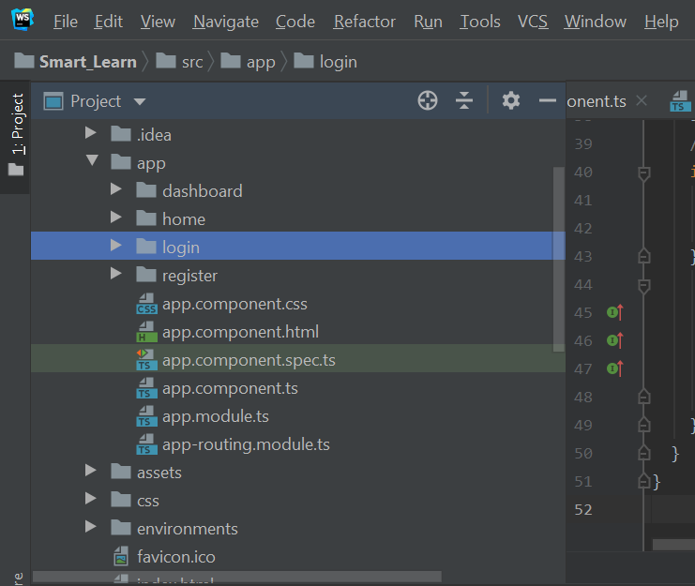

1. Added form validations for login and registration components.

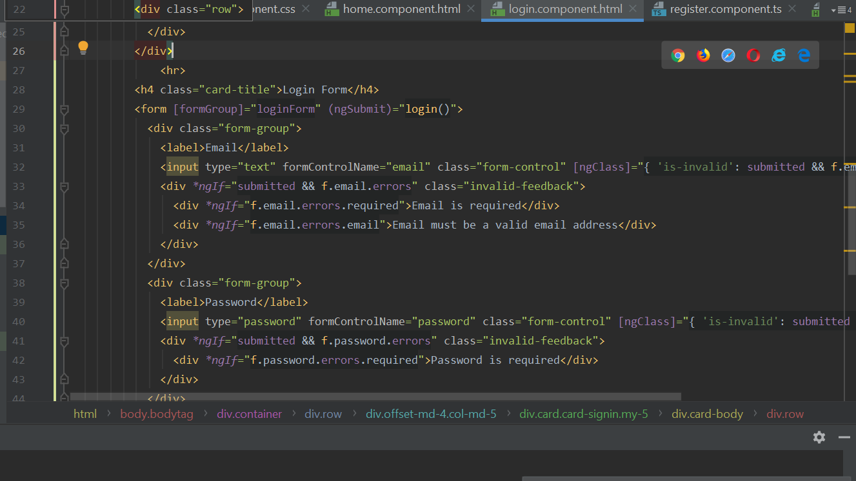

1. Added sweet alert to display success and error messages.

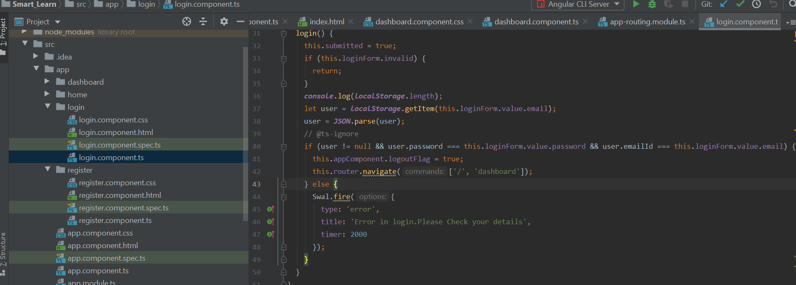

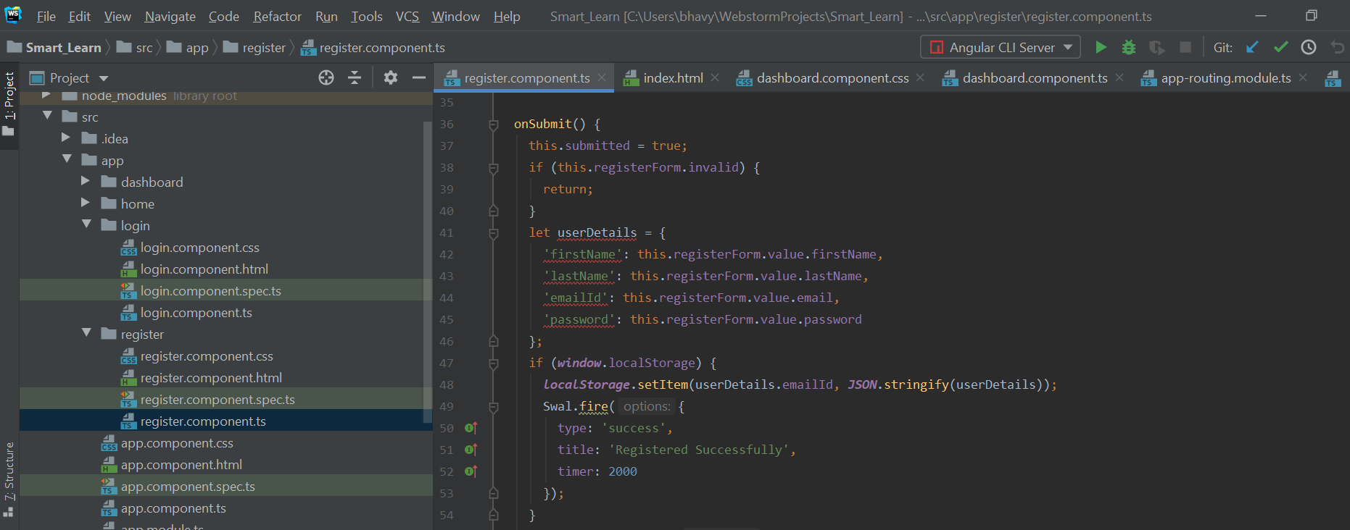

1. Added Routing module and also defined routes.

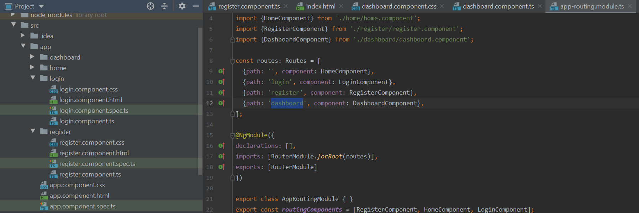

**Design:**

1. Created Logo for our application using freelogodesign.org.
2. When the application starts home page will be displayed.

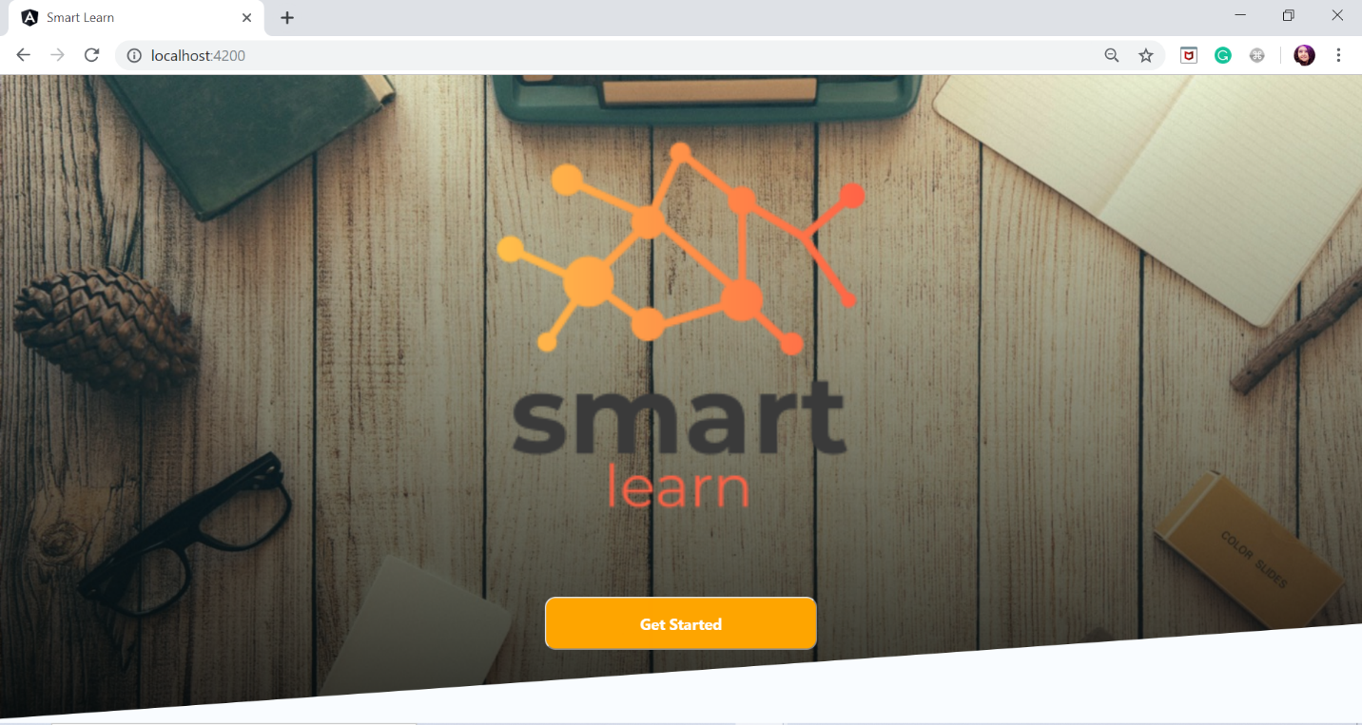

1. When user clicks on get started button it will navigate to the login page.

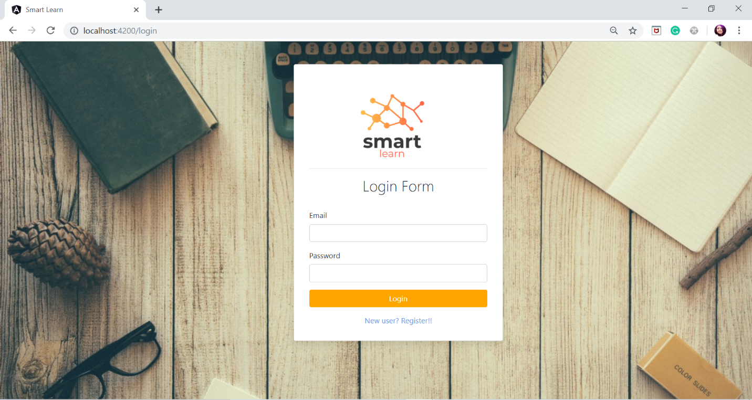

1. If the user enters the valid details, he will be redirected to the dashboard page.
2. If the user does not have any account, he can register using register link in login page. Then the user will be redirected to the registration page.

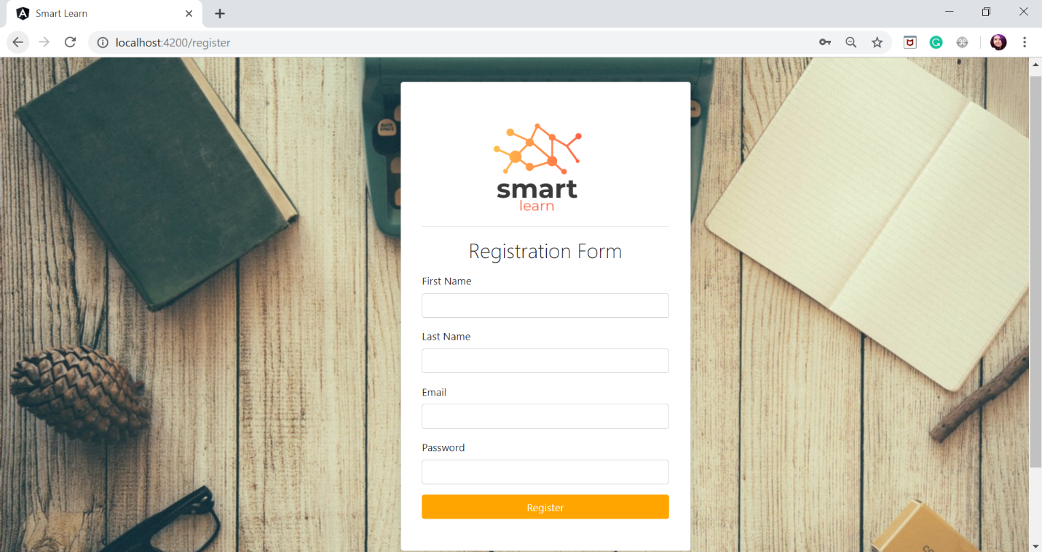

1. Displayed an alert for wrong login details and also on successful registration.

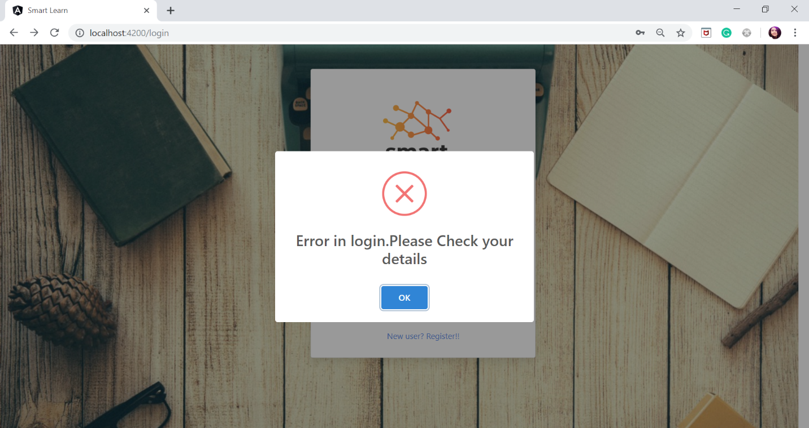

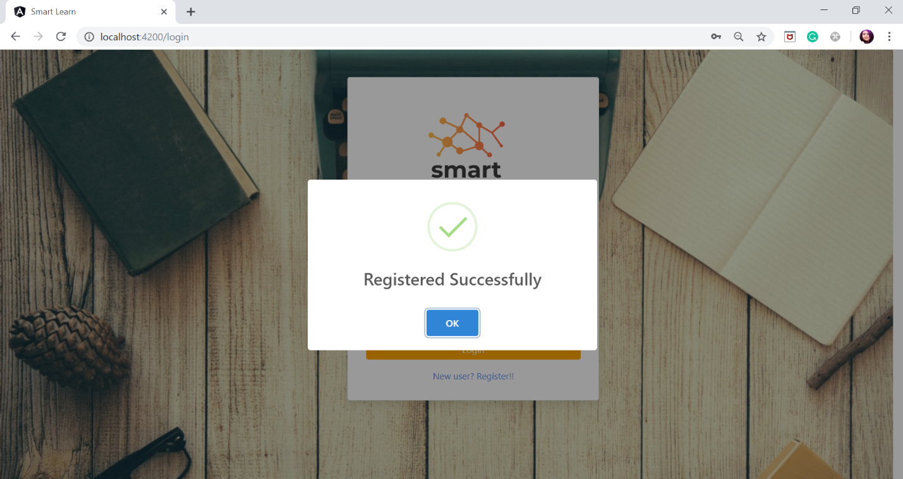

1. Displayed error messages for input validations.

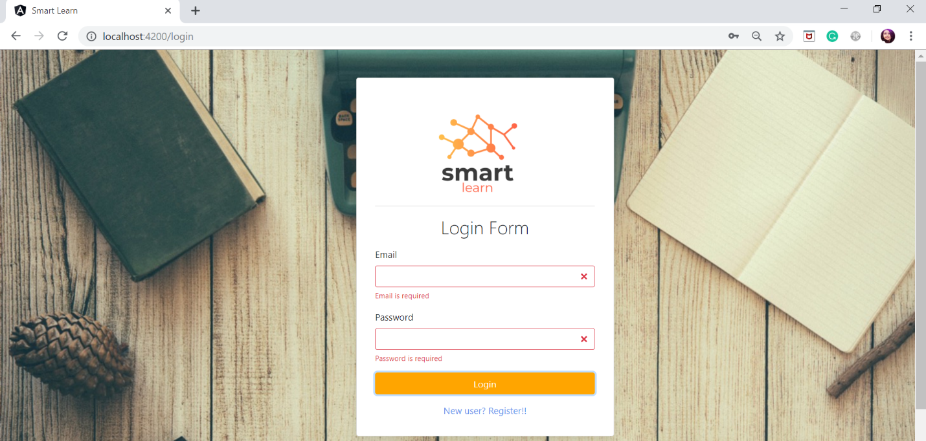

1. In the dashboard page a side nav bar and top nav bar will be displayed.

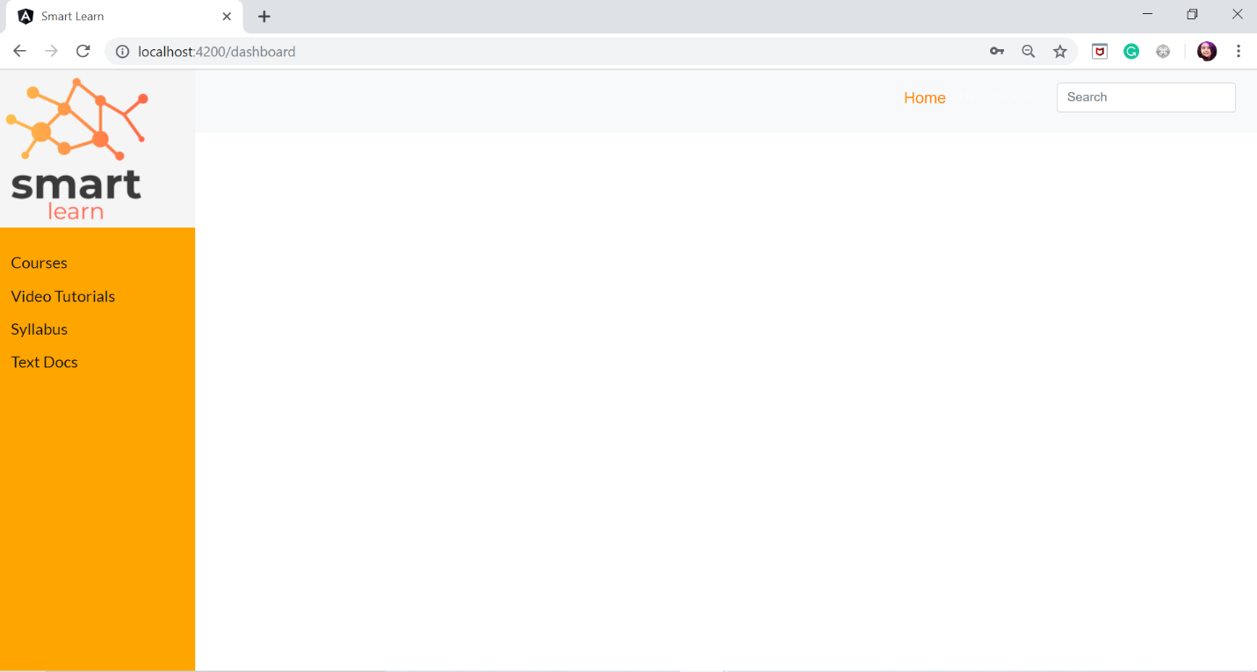

**Backend:**

**get-google-knowledge-graph** : This backend service is developed in Python, uses google serpi api to parse the google knowledge graph about the query. We will make use of related question features from google knowledge graph links to display the results from youtube or dig more in to other related technologies. This service is crucial in gathering the links about the related topics. We will dynamically pass these related links or URLs to get-youtube-videos servoce that will produce the videos.

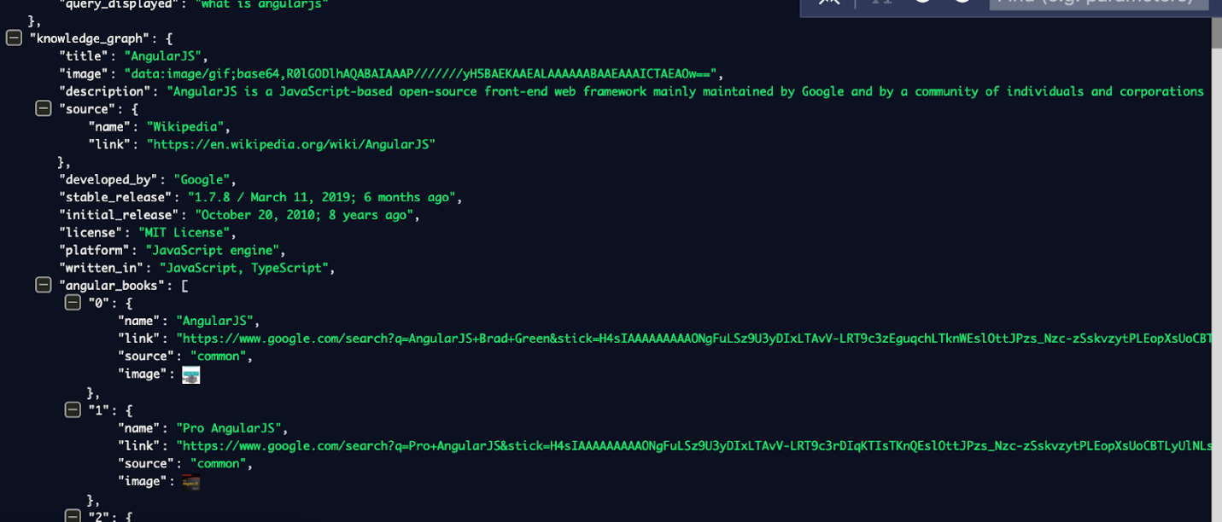

**get-youtube-videos:** This service is developed in Javascript which will just get the input from the search bar, we have optimized the search feature to only pull the recent highly viewed videos. We will replace the search bar with the dynamic input from the get-google-knowledge-graph service.

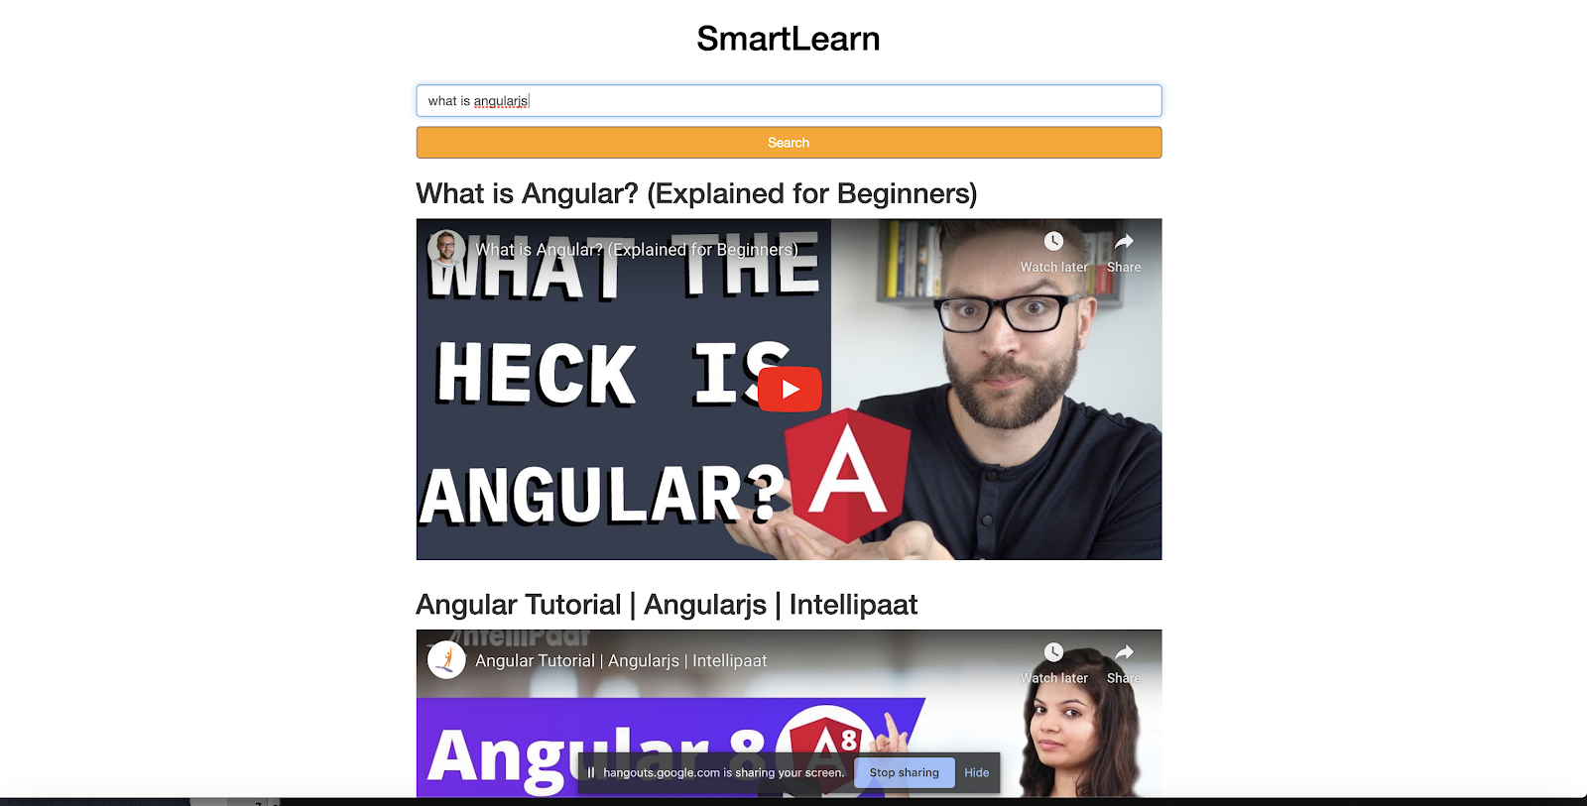

The above images show the api calls from youtube based on the search query,. The search query will be replaced by a dynamic content search from google knowledge graph. Here we are applying a knowledge graph to youtube or to dig more related content because our SmartLearn app will make sure that every search is an informational search that can benefit the student.

**Project Management:**

Created User stories in Git hub. Used Zen hub for the management of project.

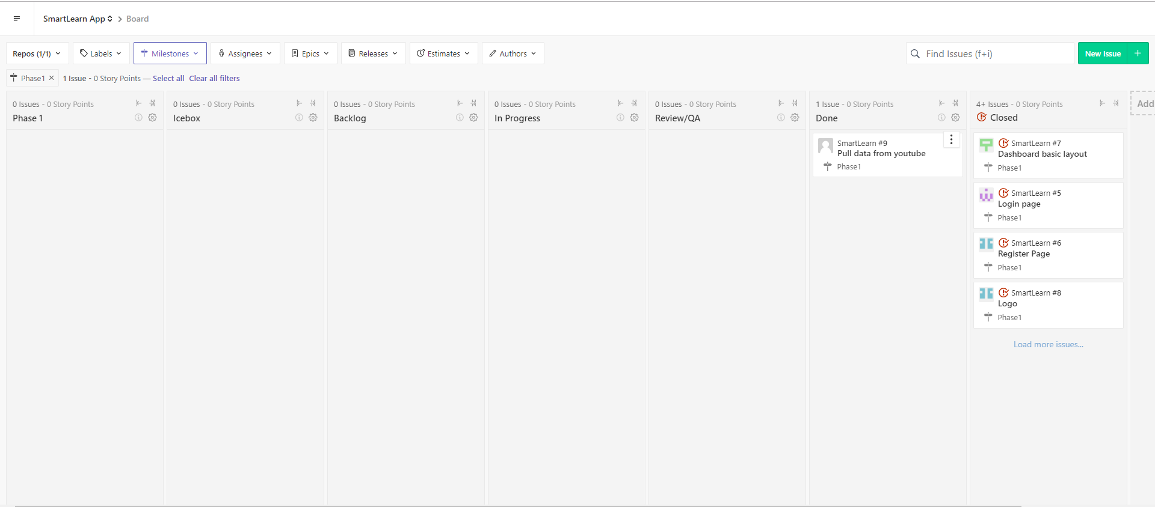

**References:**

* <https://www.w3schools.com/>
* <https://www.freelogodesign.org/>
* <https://sweetalert2.github.io/>
* <https://angular.io/guide/form-validation>
* <https://cssanimation.rocks/>
* <https://getbootstrap.com/docs/4.0/getting-started/introduction/>